**3.1) Design a web page using CSS (Cascading Style Sheets) which includes the**

**following:**

**3.1.1) Use different font, styles: In the style definition you define how each**

**selector should work (font, color etc). Then, in the body of your pages, you refer to**

**these selectors to activate the styles.**

**3.1.2) Set a background image for the web page and control the repetition of the**

**image with the background-repeat property.**

**3.1.3) Define styles for link as visited, active, hover & link.**

**3.1.1)**

html>

<head>

<title>Usage of differnt fonts, colors </title>

<link rel="Stylesheet"type="text/css"href="in.css"/>

</head>

<body style="background-color:powderblue;">

<h1>This is the Header H1 </h1>

<h2>This is the Header H2 </h2>

<h3>This is the Header H3 </h3>

<p>This is a Paragraph </p>

</body>

</html>

**HTML:**

h1

{

color:indigo;

font-family:Trebuchet MS;font-size:18t;

text-decoration:underline;

}

h2

{

color:coral;

font-family:caSteller;font-size:20pt;

text-decoration:underline;

}

h3

{

color:greenyellow;

font-family:Arial Black;font-fize:20pt;

text-decoration:blink;

}

p

{

color:magneta;

font-family:fantasy;size=15pt;

font-style:italic;

}

**OUTPUT:**

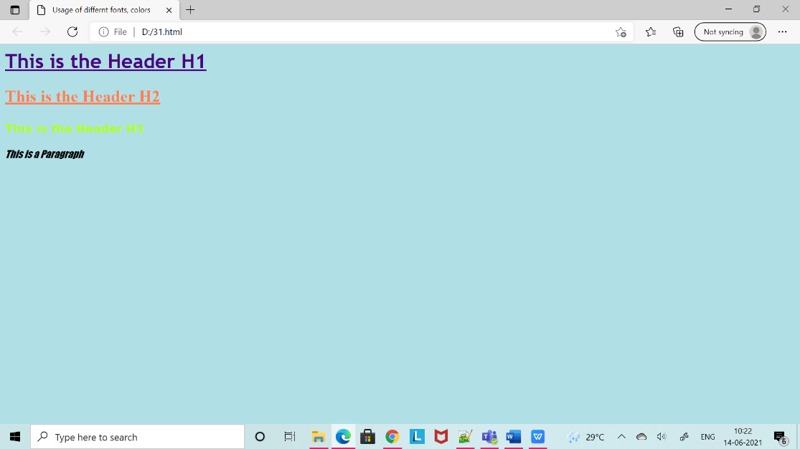

3.1.2) Set a background image for the web page and control the repetition of the

image with the background-repeat property.

<html>

<head>

<title> Background Image </title>

<style type="text/css">

body

{

background-image:url('friends.jpg');

background-repeat:no-repeat;

}

</style>

</head>

<body bgcolor="azure">

<body text="black">

<h1> Life is better with Friends </h1>

</body>

</html>

**Output:**

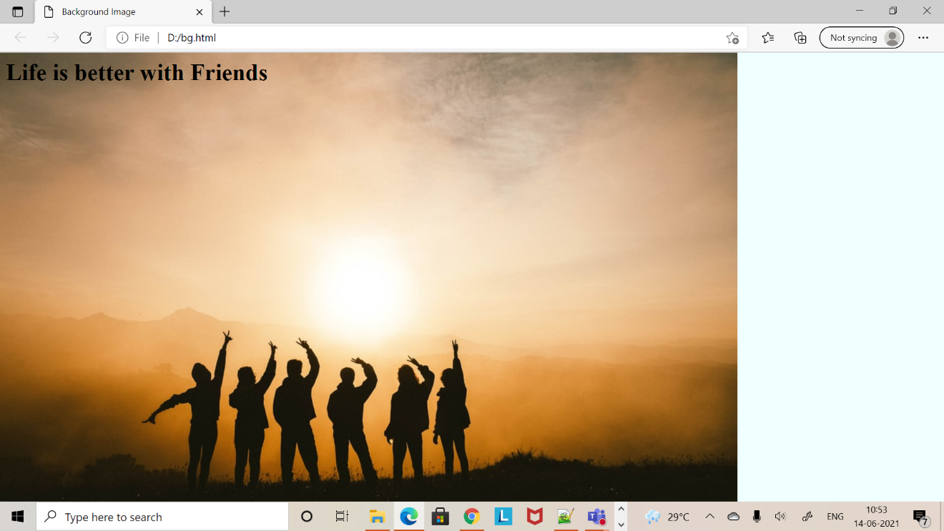

3.1.3) Define styles for link as visited, active, hover & link.

<html>

<head>

<title> CSS Webpage </title>

<style type="text/css">

body

{

background-image:url('plain.jpg');

background-repeat:no-repeat;

background-size:cover;

}

p

{

color:navy;

font-size:20pt;

font-family:coral;

background-image:url('friends.jpg');

}

a:link{font-size:20pt;background-color:white;}

a:hover{font-size:20pt;backgroud-color:pink;cursor:crosshair;}

a:active{font-size:20pt;background-color:cyan;cursor:help;}

a:visted{font-size:20pt;background-color:tan;}

</style>

</head>

<body>

<br>

<p>

Web technology refers to the means by which computers communicate with each other using markup languages and multimedia packages.

It gives us a way to interact with hosted information, like websites.

Web technology involves the use of hypertext markup language (HTML) and cascading style sheets (CSS).

</p>

<a href="link.html"><center>Register</center></a>

<br>

</body>

</html>

**Output:**

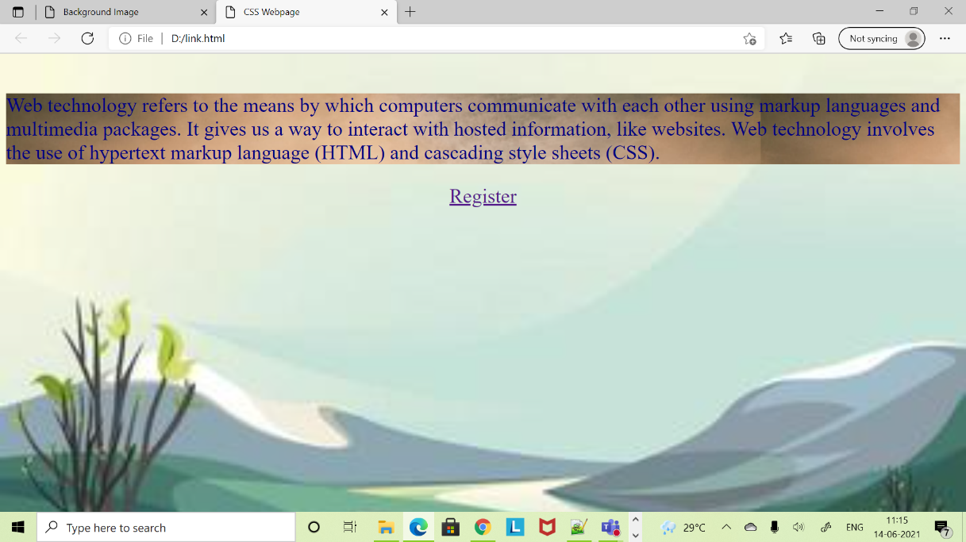

Name: Sonali Sahu

18A91A0556